**Literary Elements**

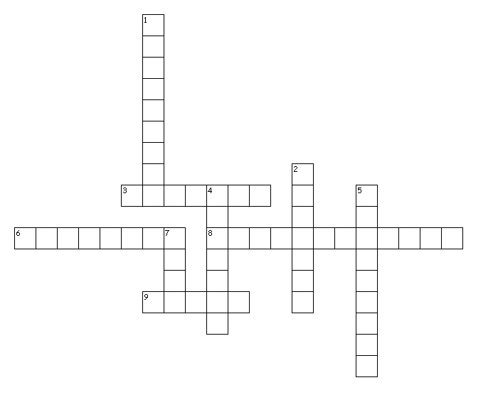

Across

3. Time and place

6. The problem or struggle between two opposing groups.

8. Use of the same consonant at the beginning of words in series

9. A kind of literary or artistic work

Down

1. The way an author or poet constructs a text

2. idea The author's message

4. Words that create a picture in the reader's mind

5. The section of a narrative that shoots back in time

7. Emotion or feeling evoked by a text